Additional document for JCER paper

Figure ii - Five Guiding Principles of Sustainable Development
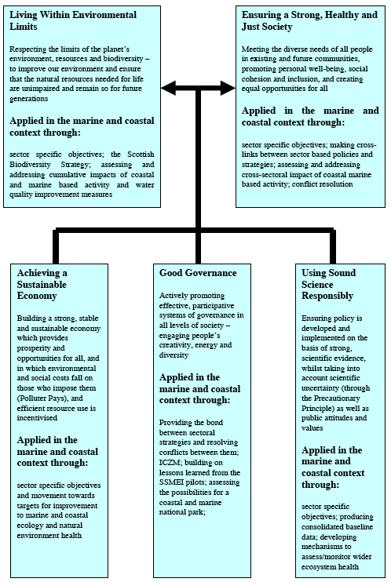
Source: Scottish Government (2005)

