Additional document for JCER paper

Figure iii – Some Participants in North Sea Pollution Prevention
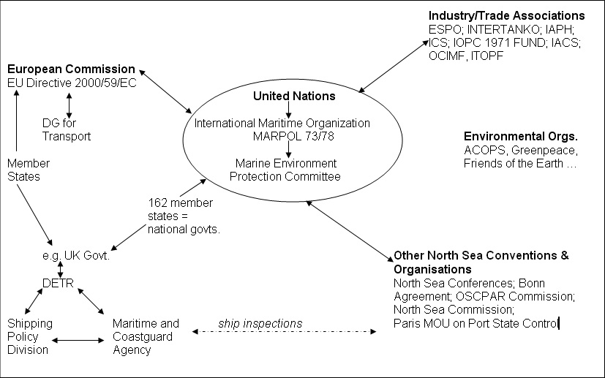

Source: Amended from Carpenter, 2005, Figure 2.1, page 22

